SECTION HC

FUEL INJECTION PUMP CONTROL LINKAGE

CONTENTS

Chapter

Description .. .. .. .. .. .. .. .. .. 1

Removal and Dismantling .. .. .. .. .. .. .. 2

Inspection .. .. .. .. .. .. .. .. .. 3

Assembly and Fitting of Longitudinal Linkage 'A' or 'B' Bank .. .. 4

Assembly and Fitting of Transverse Linkage .. .. .. .. 5

Fitting Replacement Governor .. .. .. .. .. .. 6

Special Tools.. .. .. .. .. .. .. .. .. 7

CHAPTER 1

DESCRIPTION

1. The fuel injection pumps are controlled by the governor actuator, mounted at the drive-end of the engine, which operates a mechanical linkage to move the pump racks according to engine speed and load.
2. Movement is transmitted from governor lever (13)(Fig HC.l) via an elastic link, side levers (3) and (24), and adjustable rods (1), (15), (20) and (23) to control shafts (40) and (47). Centre lever (17) reverses movement between banks so that each control shaft rotates inwards towards the pumps for 'Full Fuel'. The section of the control linkage between the governor and control shafts is the 'TRANSVERSE LINKAGE'.
3. Each pump rack is moved by a two-part assembly; spherical-end lever (106)(Fig HC.2) providing a positive movement towards 'FULL FUEL' and forked-end lever (94) providing a spring return towards 'NO FUEL'. The spherical-end levers are keyed to the control shafts, which are in turn bracket mounted to the fuel pump camboxes. This section of the control linkage is the 'LONGITUDINAL LINKAGE'.
4. Maximum and minimum fuel stop screws (85) and (107) are fitted to limit control shaft rotation, and thus fuel rack travel.
5. Hand levers (32) and (54)(Fig HC.l), one on each bank, enable the fuel racks to be returned to 'NO FUEL' in an emergency regardless of governor position. Under these circumstances plunger (10) will slide out of the elastic link against the action of springs (8) and (9). Each hand lever assembly incorporates a pointer (82), which together with indicator scale (33), shows fuel rack movement in mm. 'O' on the scale corresponds to 'NO FUEL'.
6. 'A' and 'B' bank longitudinal linkages are similar except that 'A' bank control shaft has an additional bearing bracket (28) and lever (29) for the fuel limiter.

REMOVAL AND DISMANTLING

Transverse Linkage

1. Control rods (15) and (20)(Fig HC.l) are set to specified length and split-pinned. Control rods (1) and (23) and the elastic link are set during engine test and split- pinned. The effective length of governor lever (13) is set during engine test, wire- locked and sealed. All these settings are critical as far as engine performance/ protection are concerned and should not be disturbed if it can be avoided. Therefore, where the transverse linkage has to be removed for engine dismantling but it is not necessary to renew any of the component parts, the rod-ends should be disconnected from their levers (see Para 2.3) and the rods/rod-ends removed as a unit. In this way no settings will be affected.
2. Maximum fuel stop screws (85)(Fig HC.2), one on each bank, are set to limit the amount of fuel that can be injected into the engine consistent with the contractual output requirements. After setting, stop screws are wire-locked and sealed to prevent unauthorised adjustments.
3. The securing arrangements of the various rod-ends to their respective levers are shown in Fig HC.l:-
4. To release rod-end (21) and (22) from side lever (24)(Inset C) remove plain nut (69) and withdraw fitting bolt (67). Remove rod-end and dust covers (68).
5. To release rod-ends from levers (3), (17), (45) and (30), draw gaiter clear of rod-end, remove locknut (66)(Inset B) and unscrew bolt (64) from the lever. Remove washer (65).
6. To release rod-end (12) from governor lever (13), draw gaiter (55)(Inset A) clear of rod-end, remove philidas thin nut (57) and draw rod-end off pivot bolt (56).
7. Centre Lever - Remove philidas nuts (26), and remove bracket (27) from governor mounting cover. Remove circlip (76)(Inset D) and washer (75) and withdraw spindle (77). DO NOT separate lever and spindle except to renew components, in which case remove circlip (79), loosen capscrew (19) and slide centre lever (17) from spindle.
8. Elastic Link - The link can be partially dismantled for examination of components without disturbing the overall length. A special dolly and anvil will be required to accept the elastic link complete with control rods and ball-ends, and to compress springs when removing circlip (6); there is a considerable fitted load on springs (see Para 3.6). After removing circlip (6), withdraw plunger (10) complete with springs (8) and (9), and guide washer (7). However, if it is necessary to replace inner spring (9), slacken locknut and unscrew control rod (5) from plunger (10).
9. Side Levers - Remove setbolt (73)(Inset F), washer (72) and distance piece (70).

Longitudinal Linkage - 'A' Bank

1. Remove linkage cover (35). Release springs (93)(Fig HC.2) from spherical-end levers (106) and remove forked-end levers (94) complete with springs.
2. Release and remove return spring (39)(Fig HC.l).
3. Push all pump racks towards 'FULL FUEL' and rotate control shaft (40)(Fig HC.2) towards 'NO FUEL' thereby disengaging ball-ends (115) from adjusting screws (91).
4. Bend back tabwashers and remove setscrews securing bearing brackets to cambox. Ease control shaft bearing brackets from their dowel location with the cambox. Remove drive-end bearing bracket (28).
5. DO NOT remove or alter position of adjusting screws (91) except to renew or unless a new fuel injection pump is to be fitted. Should this be necessary, slacken philidas nut (117), unscrew adjusting screw (91) and remove washer (90). Release bellows (124) from retaining plate (123) and separate bellows and adaptor (122). For additional information regarding the fuel injection pump refer to Section GF.
6. Slacken capscrew (43)(Fig HC.3) and slide fuel limiter lever (29) off control shaft. Remove key and circlip.
7. Remove circlip, slacken capscrew and slide operating lever (30) off the shaft. Remove key and circlip.
8. Slacken setscrew (38) and slide pointer of hand lever (32) off shaft. Remove key.
9. Slide stop bracket (36) off shaft. DO NOT alter setting of maximum fuel stop- screw (85)(Fig HC.2) which is wire-locked and sealed, or minimum fuel stop screw (107) which is locked by pin (108) and cannot be adjusted.
10. Slacken capscrew and slide stop lever (87) off shaft. Remove key.
11. Slacken capscrew and slide spherical-end lever (106) off shaft. Remove key.
12. Continue removing remaining levers and brackets, slackening grubscrews (101) and removing stop collars (102) at the appropriate bearing bracket.
13. Remove circlips (116) and ball-ends (115). Discard circlips.

Longitudinal Linkage - 'B' Bank

1. The dismantling sequence is similar to that detailed for 'A* bank except there is no outboard bearing and lever at the drive-end of the control shaft.

CHAPTER 3

INSPECTION

1. Measure all rod-ends for wear. The rod-ends should be renewed if there is 0.127 mm (0.005 in.) movement between the centre ball and outer casing. Check that control rods are not bent.
2. Examine bearing bushes fitted to centre lever bracket, side levers and control shaft bearing brackets. If a movement of 0.127 mm (0.005 in.) can be measured between shaft and bush, the bush should be replaced. Similarly, bushes should be renewed if bearing surfaces are badly scored or worn away at one point. Excessive clearances at these points, and in particular between the spindle and bushes of the centre lever, will result in lost motion which could cause governor 'hunting' or difficulties in balancing fuel racks between banks. DO NOT attempt to scrape or ream bushes as this will destroy the special self-lubricating bearing surface rendering them unfit for further use.
3. Examine centre lever spindle (77)(Fig HC.l) and side lever distance pieces (70) for scoring. Such marks may be blended in with a fine oilstone, but do not overwork as this may result in excessive clearances and governor 'hunting'.
4. Examine chromium plating on control shafts for cracking or flaking and shaft keyways for cracking. Check all drive keys for fretting.
5. Examine ball-ends (115)(Fig HC.2), spherical-end levers (106), adjusting screws (91), washers (90) and forked levers (94) for wear. Renew as necessary. All of these items have been subjected to a process which results in a discoloured coating. No attempt should be made to remove this coating.
6. Examine elastic link, plunger and guide washer for wear or high spots. Lightly clean any such marks. Check the springs for collapse or damage. When new, the springs conform to the following :-

Inner Spring

Load at 120 mm (4 3/t in) Renew if load is less than

17.25- 19.0 kg (38 - 42 lb)

1. kg (36 lb)

Outer Spring

Load at 120 mm (4 3/4 in) 20.0 - 21.75 kg (44 - 48 lb)

Renew if load is less than 19.0 kg (42 lb)

1. Examine control shaft return springs and forked lever springs for opening at eyes and for coil separation. Check for wear caused by fouling with adjacent components which will weaken springs. When new springs conform to the following:-

Control Shaft Return Spring

Load at fitted length of 98.5 mm (3.875 in) - 7.25 kg (16 lbf).

Forked Lever Spring

Load at fitted length of 35 mm (1.375 in) - 2.8 kg (6.25 lbf)

1. Examine all gaiters and bellows (124) for cracking, distortion, or hardening. Renew if necessary.
2. Check all threaded components for serviceability. Check that all locating dowels are in good condition. Check all circlips for distortion, renew if necessary.

ASSEMBLY AND FITTING OF LONGITUDINAL LINKAGE

'A' OR ’B’ BANK

NOTE All joints and 'O' rings must befitted dry.

1. Press new bushes into bearing brackets for control shaft.
2. Apply a molygrease such as 'MOLYRACE' to ball-ends (115)(Fig HC.2) fit to spherical-end levers (106), and secure with new circlips (116). Ensure that circlips are fully bedded in their grooves.
3. Place control shaft in notched wooden blocks; DO NOT use steel 'V' blocks as these could damage surface finish of of shaft.

NOTE Fig HC.3 shows longitudinal linkage suitable for an 18 cylinder engine. 8, 12 and 16 cylinder engines are similar in all respects except for reduced number of spherical-end levers and bearing brackets. On 8 and 12 cylinder engines stop collars (102) are fitted at Position 'X' instead of Position 'Y'.

1. Referring to Fig HC.3 slide a low-profile bearing bracket (103) and two stop collars (102) into position. Temporarily tighten stop collar grubscrews (101).
2. Fit keys to shaft keyways either side of stop collars, slide spherical-end levers over keys, centralise and tighten capscrews. Continue fitting bearing brackets and spherical-end levers (alternately fitting low profile and cover support brackets) finishing at free-end and drive-end spherical-end levers.
3. Fit key and stop lever (87)(Fig HC.2), centralise and tighten capscrew (89).
4. Slide a stop bracket into place, locating stop lever between maximum and minimum fuel stop screws.
5. Fit key, a hand lever/pointer, spring anchor plate and setscrew. Centralise pointer and tighten setscrew.
6. Fit a circlip and key. Slide an operating lever into position against circlip and fit second circlip. Tighten capscrew.
7. Fit circlip and key ('A' bank control shaft only). Slide fuel limiter lever (29) into position against circlip and tighten capscrew.
8. Check that adjusting screws (91) are fitted to all pump racks (121). If necessary, assemble washer (90), philidas nut (117), bellows (124) and adaptor (122) to adjusting screw and screw into pump rack (121). Temporarily tighten philidas nut and fit bellows over retaining plate (123) and adaptor (122). For additional information regarding fuel injection pump refer to Section GF.
9. Push all fuel injection pump racks into pumps.
10. Slacken grubscrews (101) in stop collars (102) and offer up complete assembly to cambox, locating the dowels in low profile and stop brackets with the cambox. (When fitting 'A' bank assembly it will be necessary to fit and hold the drive-end and free-end brackets in place whilst fitting shaft). Position remaining bearing brackets and secure to cambox with tabwashers and setbolts of the correct length. Tighten and lock.
11. Engage all pump racks with spherical-end levers. Place washers (90) against adjusting screw, and forked-end levers (94) against washers and control shaft. Fit retaining springs (93).
12. Centralise spherical-end levers with adjusting screw by moving control shaft longitudinally. If necessary, individual levers may be moved on the shaft to obtain optimum alignment. Position stop collars to maintain this alignment and to allow control shaft end float of 0.13 mm. Check that stop lever and control shaft pointer are not rubbing against stop bracket or indicator scale block at extremes of end float. Adjust position of these levers to obtain a minimum clearance of 1.3 mm. Finally check that all clamping capscrews are tight; it is most important to ensure that clamping action is positive.
13. Move pointer (82)(Fig HC.l) to gauge position on indicator scale (33) and insert setting pin (81)(see Chapter 7) through the pointer to locate with the reamed hole in indicator scale mounting (80).
14. Peel bellows (124)(Fig HC.2) back clear of adaptor (122). Slacken philidas nut (117) and adjust effective length of pump rack (121) by means of adjusting screw (91) until gap gauge (125) is a sliding fit between adaptor (122) and pointer plate (119). Make certain that gap gauge is between adaptor and pointer plate and NOT between adaptor and retaining plate (123). Tighten philidas nut and re-check. Refit bellows (124).

NOTE Philidas nut (117) should only be slackened sufficiently to allow adjusting screw to be moved. Excessive slackening will allow adaptor (122) to tilt and a false reading will be obtained.

1. Repeat the above for ALL injection pump racks.
2. Remove setting pin and check control shaft for freedom of movement between maximum and minimum fuel stops. Also check that each pump rack moves with its spherical-end lever, ie is not jamming partially open.

CAUTION AFTER SETTING IN THE ABOVE MANNER NO INDIVIDUAL ADJUSTMENTS OF FUEL INJECTION PUMP RACKS BY REFERENCE TO EXHAUST TEMPERATURES IS PERMITTED.

ASSEMBLY AND FITTING OF TRANSVERSE LINKAGE

NOTE All joints and 'O' rings must befitted dry.

1. Referring to Section HA and Chapter 6 of this section, fit governor to mounting cover (25)(Fig HC.l).
2. Press new bushes (74) into bore of bracket (27). Fit circlip (76) and washer (75) to spindle (77) and insert spindle into bracket. Slide centre lever (17) onto spindle with bossed side towards bracket. Fit washer (78) and circlip (79). Adjust lever to give an end float of 0.13 - 1.25 mm, and tighten capscrew (19). It is important to ensure that clamping action of capscrew is positive, ie that a capscrew of the correct length is used so that there is no possibility of it 'bottoming'. Also ensure that circlips are in good condition and secure in their grooves. Fit complete assembly to mounting cover (25) and secure with philidas nuts (26).
3. Press new bushes (71) into bore of side lever (3). Fit lever, together with setbolt (73), distance piece (70) and washer (72) to 'B' bank side of governor mounting cover. Adjust length of distance piece, if necessary, to obtain an end float of 0.05 -
4. 30 mm.
5. Repeat for side lever (24).
6. Intermediate control rods (15) and (20) - Assemble gaiters (55), locknuts and rod- ends to control rods. Adjust length between rod-end centres to following dimensions:-

Short rod (15) 147.5 mm ± 0.25 mm

Long rod (20) 197.0 mm ± 0.25 mm

Tighten locknuts ensuring that rod-ends are aligned. Drill for and fit split pins.Connect rods between centre lever (17) and side levers (3) and (24).

1. Lock side lever (3) by connecting setting gauge (126) (Fig HC.4)(see Chapter 7) between governor output shaft (127) and hole normally occupied by rod-end (4)(Fig HC.l). The larger bore in setting plate just slides onto output shaft whilst smaller bore should be secured to lever with a rod-end bolt. Check that centre lever is as shown in Fig HC.l; until linkage is locked it is possible for lever to 'invert' giving incorrect rack movement on one bank of fuel pumps.
2. Assemble gaiters, locknuts and rod-ends to control rod (1), one end of rod has a left hand thread, and connect rod between side lever (3) and operating lever (45). Adjust length of rod so that setting pin (81)(see Chapter 7) slides easily through pointer (82) and into reamed hole in indicator scale mounting (80). Tighten locknuts ensuring that both rod-ends are aligned and re-check. Repeat for control rod (23).
3. Governor lever - Check that governor lever length is correct for power output of engine. The effective length of the lever is adjustable and an indication is given by the relationship of incised line (84) with indicator plate (62). The lever is set during engine test, wire-locked and lead sealed, and setting recorded on Engine Test Sheets. Normally it should not be necessary to alter this setting, especially if lever has already been run satisfactorily on the engine. However, if due to damage a new lever has to be fitted, slacken grubscrew (59) and adjust centre screw (61) to position pivot bolt (56) at required length. Tighten grubscrew (59) BEFORE tightening philidas thin nut. Fine adjustments to lever may have to be carried out during engine testing.
4. Elastic link - Lubricate component parts, with a moly grease such as 'MOLYRACE'. Insert plunger (10), springs (8) and (9) into handpiece (11), fit guide washer (7) and circlip (6). Screw rod-end (12) complete with gaiter and locknut into handpiece (11). Screw rod-end (4) complete with locknuts and control rod (5) into plunger (10). Adjust length of assembly to 282.5 mm between rod-end centres and tighten locknuts. Fit plain washer (58) and rod-end (12) to pivot bolt (56) and secure with philidas thin nut (57).
5. Remove setting gauge (126)(Fig HC.4) and connect rod-end (4)(Fig HC.l) to side lever (3). Remove capscrew (63) COMPLETELY. With setting pins (81) still located in indicator scale mounting and governor held at position '2' on governor output scale, offer up governor lever (13) to output shaft serrations. If serrations do not coincide adjust length of elastic link to permit governor lever to engage cleanly. No adjustment greater than half a serration should be necessary. Fit and tighten capscrew (63).
6. Remove both setting pins and check complete linkage for freedom of movement between maximum and minimum fuel stops.
7. After checking for freedom of movement, re-check that both setting pins can be inserted easily into indicator scale mountings with governor held at '2'. This is an important check which ensures that engine can be shut down, and it MUST ALWAYS BE CARRIED OUT AFTER ANY ADJUSTMENT TO THE LINKAGE. When checking, linkage should be moved by operating it from governor lever. To obtain sufficient leverage an adjustable spanner may be used on the lever which is of square section. To ensure all lost motion is taken up towards shutdown, linkage should first be moved to ’NO FUEL’ and then brought up to '2' on the governor output scale. For the same reason, return springs (39) and (48) should always be in place when check is carried carried out. If pins cannot be inserted, adjust control rods (1) and (23). WITHDRAW BOTH PINS AFTER CHECKING.
8. Move linkage from 'NO FUEL' towards 'FULL FUEL' until it just contacts maximum fuel stops without extending elastic link. Check that governor output scale is reading approximately:-

Torque Limitation Governor: 8.8

Standard Governor 8.0 to 8.5

1. The foregoing instructions are of a preliminary nature. Further minor adjustments to governor lever length and side control rods are almost inevitable after engine has been run on load. One adjustment will affect the other, ie. increasing length of governor lever will result in reduced governor shaft movement to obtain same rack travel, whilst altering side rod lengths will change the position of governor movement relative to rack travel, and it will be necessary to balance out on both to obtain the required result. After each adjustment repeat the check detailed in Para 5.12.

FITTING REPLACEMENT GOVERNOR

NOTE All joints and 'O' rings must be fitted dry.

CAUTION CARE MUST BE TAKEN WHEN TRANSPORTING GOVERNORS TO PROTECT OUTPUT SCALE/POINTER AND ELECTRICAL SOCKETS. DAMAGE OR MIS-ALIGNMENT, PARTICULARLY TO THE INDICATOR SCALE AND POINTER, WILL NECESSITATE RECALIBRATION OF THE GOVERNOR ON A TEST RIG.

1. Remove electrical connections at unserviceable governor.
2. Drain oil from governor. Remove lubricating oil piping to and from booster unit.
3. Remove any piping in way of governor removal.
4. Remove capscrew (63)(Fig HC.l) COMPLETELY and slide governor lever (13) off the output shaft.
5. Remove philidas nuts and plain washers, and lift governor from engine.
6. Withdraw drive shaft and check condition.
7. Fit a new 'O’ ring and joint to spigot of replacement governor. Refit governor drive shaft and lift governor into position, locating it with drive shaft. Fit plain washers and philidas nuts and tighten securely.
8. Connect booster unit lubricating oil piping.
9. Using a clean funnel, fill governor with engine oil to 'FULL' level marked on sight glass, vent booster unit (air operated type) and top-up governor oil level.
10. Move pointer (82)(Fig HC.l) to 'GAUGE' position on indicator scale (33). Insert setting pin (81)(see Chapter 7) through pointer to locate with the reamed hole in indicator scale mounting (80). Fit a second setting pin in a similar manner to opposite bank of engine.
11. Connect rod-end (4) to side lever (3). The securing arrangement is shown in Inset B.
12. Hold governor at position '2' on governor output scale. Offer up governor lever
13. to output shaft serrations. If serrations do not coincide adjust length of elastic link to permit lever to engage cleanly. No adjustment greater than a half serration should be necessary. Fit and tighten capscrew (63).
14. Remove both setting pins and check the linkage for freedom of movement between maximum and minimum fuel stops.
15. Carry out check detailed in Para 5.11.
16. Replace piping removed and check linkage does not foul. Remake all electrical connections.

CHAPTER 7

SPECIAL TOOLS

The following special tools are sufficient for carrying out all general maintenance, dismantling, overhaul and assembly operations on the fuel injection pump control unit as detailed in this section.

NOTE These tools are only shown in the Illustrated Parts List if they have been ordered as part of the contract.

|  |  |  |
| --- | --- | --- |
| DESCRIPTION | PART NO | USE |
| Setting pin | Y3J70878A | To locate longitudinal control shafts at 'GAUGE' position. |
| Gap gauge | Y3J70661 | To set fuel injection pump racks with longitudinal shafts at 'GAUGE' position. |
| Setting gauge | Y3J72928B | To set transverse linkage to governor output shaft. This gauge is not supplied and should be manufactured to dimension given in Fig HC.4. |

Key To Numbers

1. Control rod, 'B' bank
2. Capscrew
3. Rod-end, female
4. Operating lever
5. Circlip
6. Control shaft 'B* bank
7. Return spring
8. Setscrew
9. Spring anchor plate
10. Stop bracket
11. Linkage cover
12. Setscrew
13. Hand lever/pointer 'A' bank
14. Gaiter
15. Pivot bolt
16. Philidas thin nut
17. Plain washer
18. Grubscrew
19. Locating ball
20. Centre screw
21. Indicator plate
22. Capscrew
23. Rod-end bolt
24. Gaiter washer
25. Locknut
26. Fitting bolt
27. Dust covers
28. Plain nut
29. Distance piece
30. Bushes
31. Washer
32. Setbolt
33. Bushes
34. Washer
35. Circlip
36. Spindle
37. Washer
38. Circlip
39. Indicator scale mounting
40. Setting pin
41. Pointer
42. Lead seal
43. Incised line
44. Rod-end, female L/H thread
45. Side lever, 'B' bank
46. Rod-end, female
47. Control rod, elastic link
48. Circlip
49. Guide washer
50. Spring - outer
51. Spring - inner
52. Plunger
53. Handpiece
54. Rod-end, male
55. Governor lever
56. Rod-end, female
57. Intermediate control rod 'B' bank
58. Rod-end, female
59. Centre lever
60. Rod-end, female
61. Capscrew
62. Intermediate control rod 'A' bank
63. Rod-end, female
64. Rod-end, female L/H thread
65. Control rod, 'A' bank
66. Side lever, 'A' bank
67. Governor mounting cover
68. Philidas nut
69. Mounting bracket
70. Drive-end bearing
71. Fuel limiter lever
72. Operating lever
73. Rod-end, fern ale
74. Hand lever/pointer 'B' bank
75. Indicator scale
76. Setscrew
77. Linkage cover
78. Stop bracket
79. Spring anchor plate
80. Setscrew
81. Return spring
82. Control shaft, 'A' bank
83. Capscrew
84. Circlip

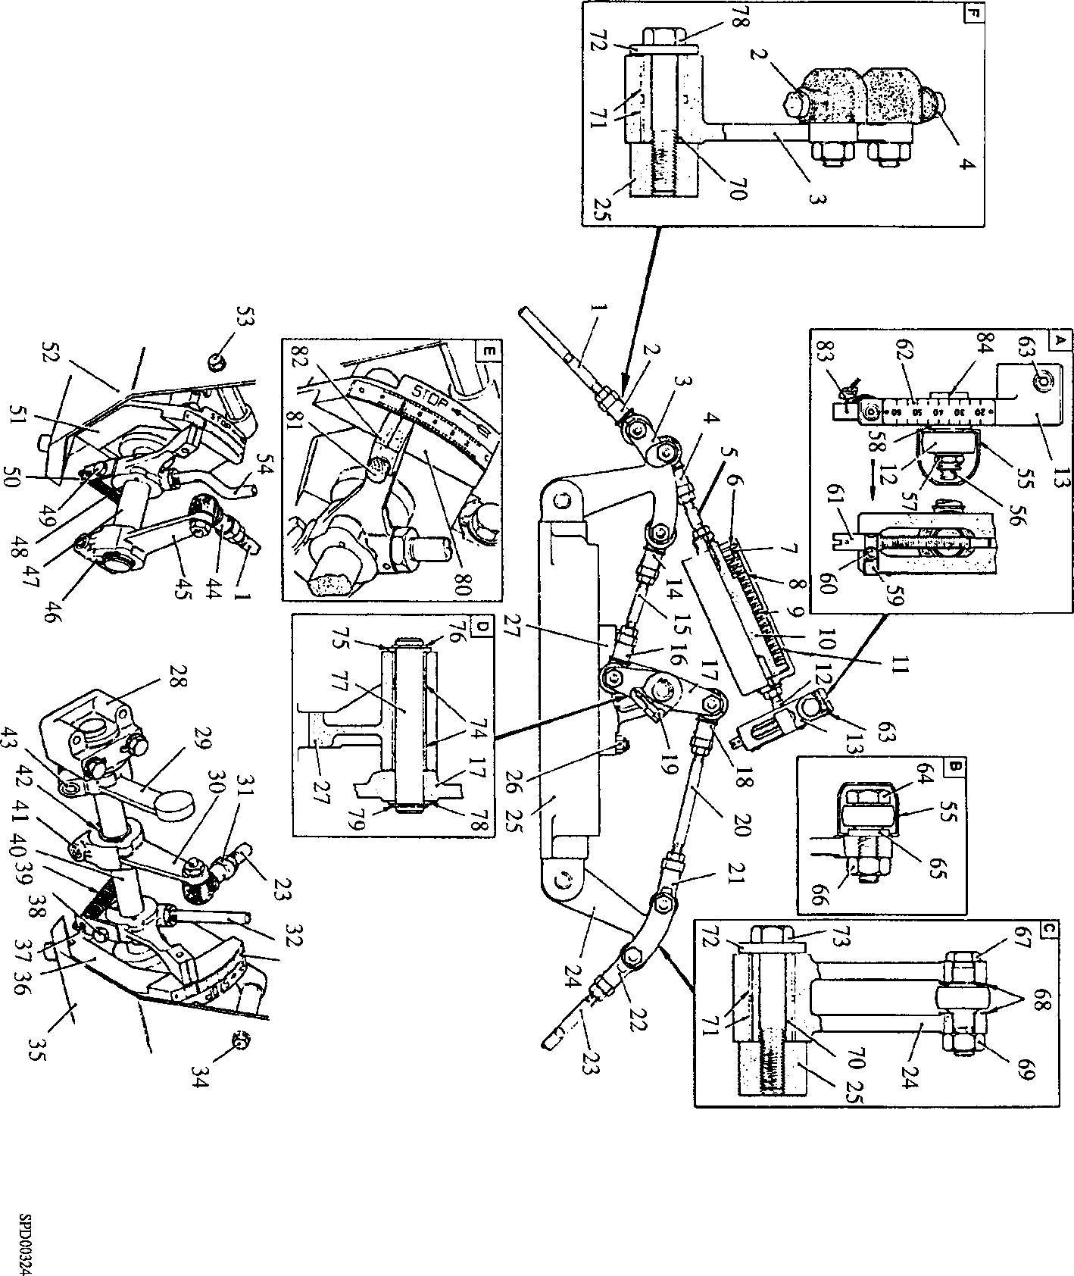

**Fig HC.l Fuel injection pump transverse linkage**

1. Grubscrew

|  |  |
| --- | --- |
| Key To Numbers | |
| 23. | Control rod, 'A' bank |
| 28. | Drive end bearing |
| 29. | Fuel limiter lever |
| 30. | Operating lever |
| 31. | Rod-end, male |
| 32. | Hand lever |
| 36. | Stop bracket |
| 40. | Control shaft 'A' bank |
| 41. | Capscrew |
| 43. | Capscrew |
| 85. | Maximum fuel stop screw |
| 86. | Lock wire and seal |
| 87. | Stop lever |
| 88. | Setbolt |
| 89. | Capscrew |
| 90. | Washer |
| 91. | Adjusting screw |
| 92. | Fuel injection pump |
| 93. | Spring |
| 94. | Forked-end lever |
| 95. | Plain nut |
| 96. | Setbolt |
| 97. | Tabwasher |
| 98. | Fuel pump cambox |
| 99. | Dowel |
| 100. | Bearing bracket |

1. Stop collars
2. Bearing bracket
3. Setbolt
4. Capscrew
5. Spherical-end lever
6. Minimum fuel stop screw
7. Locking pin
8. Tabwasher
9. Setbolt
10. Circlip
11. Circlip
12. Setbolt
13. Drive key
14. Ball-end
15. Circlip
16. Philidas nut
17. Cheesehead screw
18. Pointer plate
19. Shims
20. Pump rack
21. Adaptor
22. Retaining plate
23. Bellows
24. Gap gauge

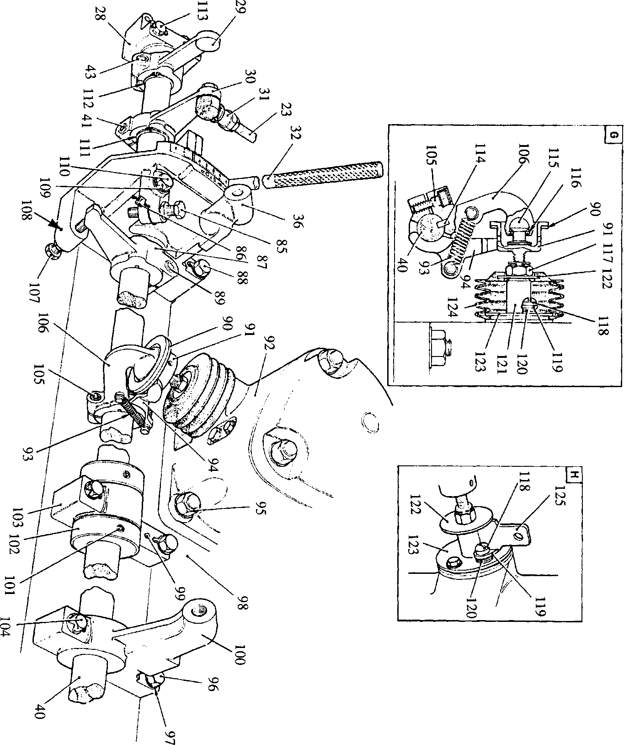

**SPD00325**

**Fig HC.2 'A' Bank longitudinal linkage**

Key To Numbers

1. Drive end bearing
2. Fuel limiter lever
3. Operating lever

32. Hand lever

36. Stop bracket

1. Setscrew
2. Capscrew

87. Stop lever

1. Grub screw
2. Stop collars
3. Bearing bracket 106. Spherical-end lever
4. Ball-end
5. Circlip

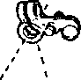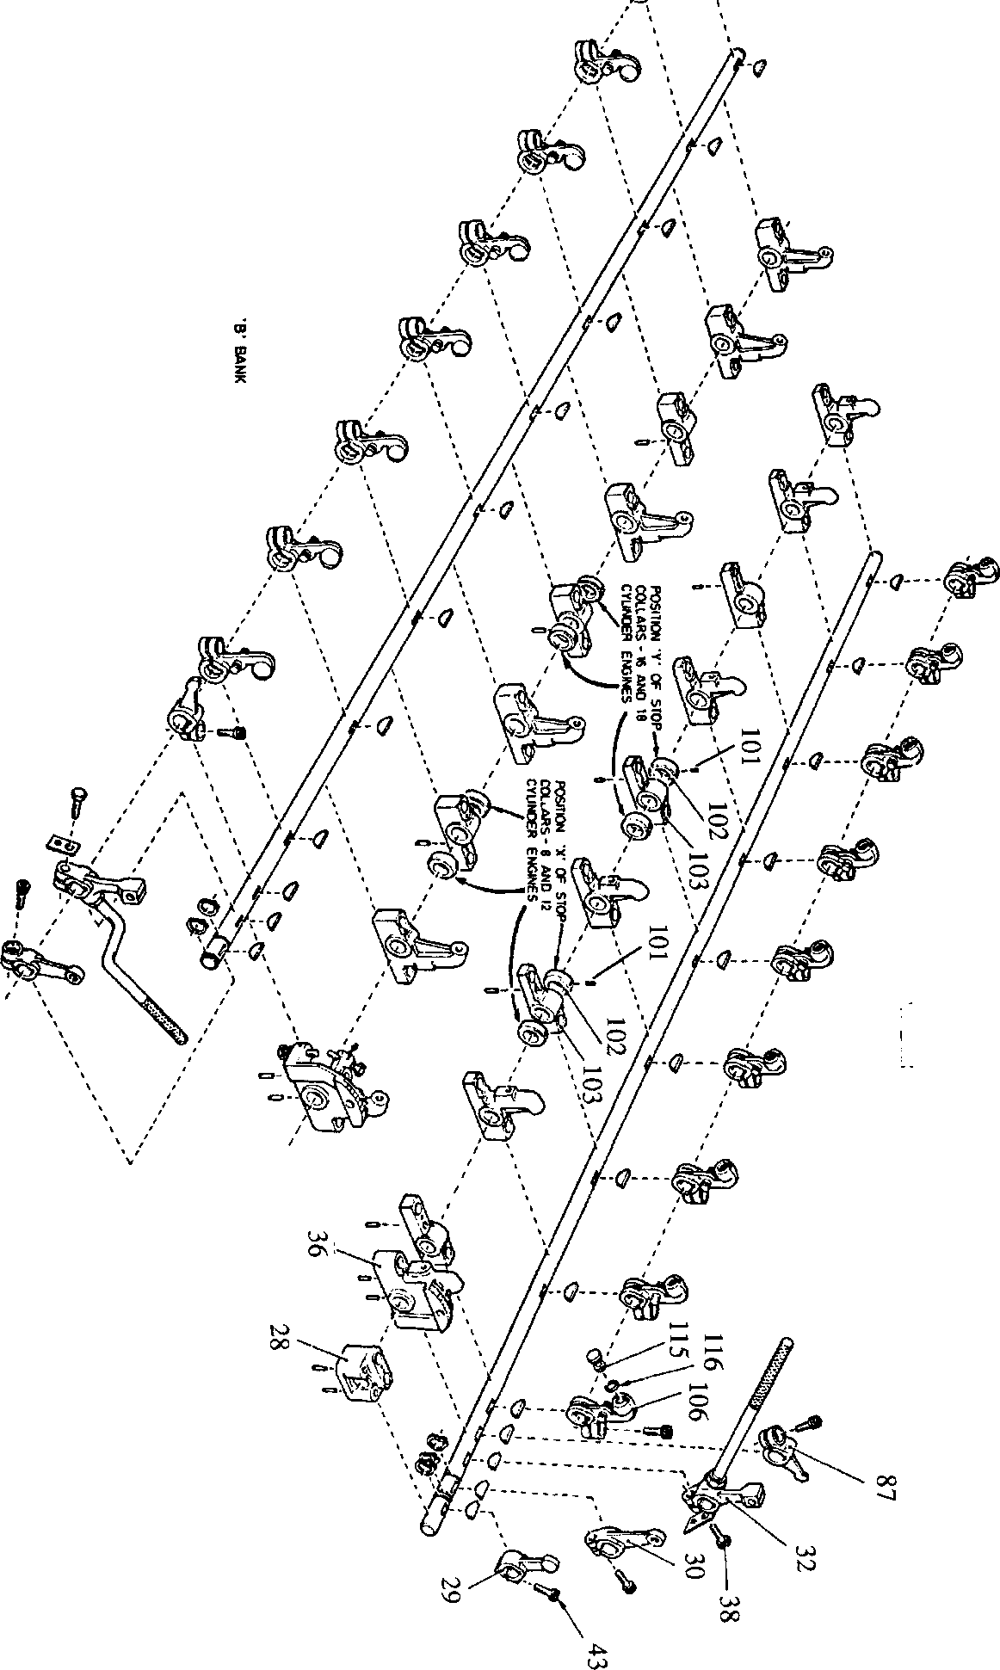

**SPD00326**

**'A' BANK**

Fig HC.3 Assembly of longitudinal linkage

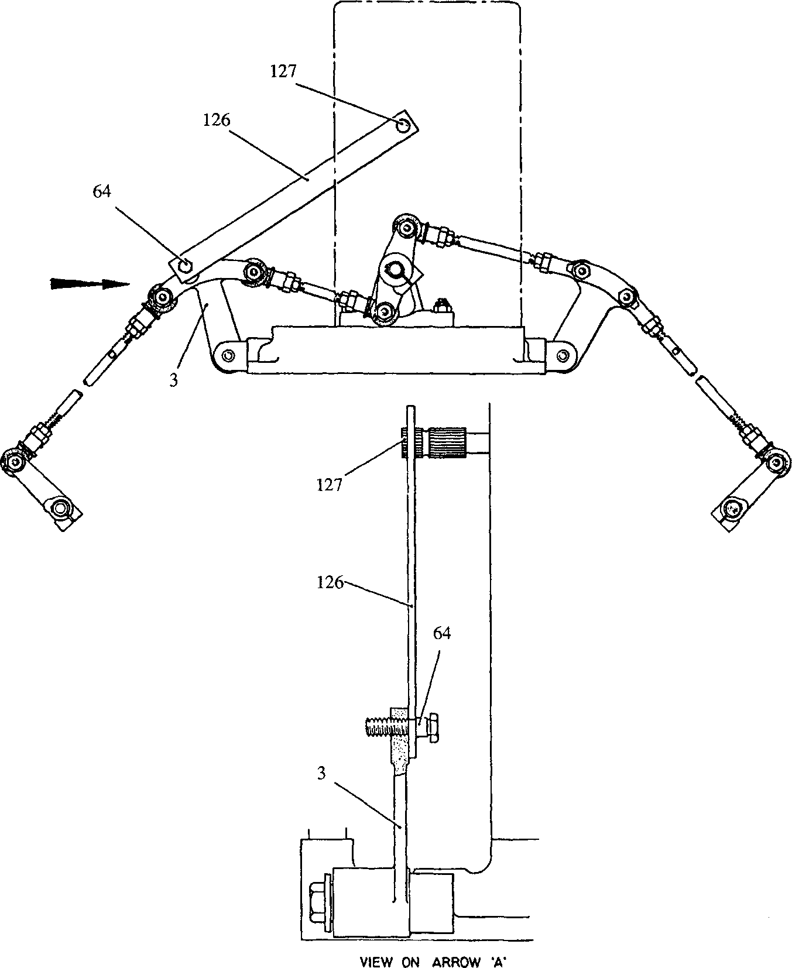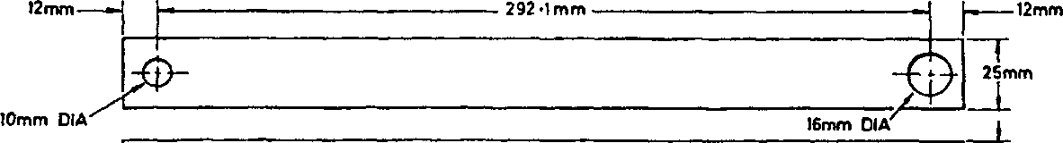

DIMENSIONS OF SETTING GAUGE

T

***imm***

**SPD00327**

Key To Numbers

3. Side lever ’B’ bank

64. Rod-end bolt

Fig HC.4